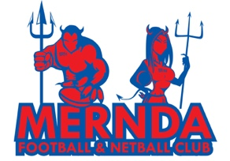

MJFC: code of conduct (GENERAL)

Our commitment

Purpose
This summary outlines the core expectations for all members of MJFC—players, coaches, team managers, parents, committee and spectators. It highlights the shared values of safety, respect, inclusion, integrity, and community spirit, while referencing the detailed role-specific Codes of Conduct for further guidance.

Core Principles

1. Safety and Wellbeing
- Priorities the physical, emotional, and psychological safety of all participants.
- Respect injury management and return-to-play guidelines.
- Safeguarding applies to everyone—players, coaches, volunteers, parents, and spectators.
- Always use respectful and supportive language.

2. Respect and Inclusion
- Recognize and respect the rights, identities, and dignity of all individuals.
- Use inclusive language and support diverse participation.
- Promote a harassment-free and discrimination-free environment.
3. Integrity of Sport
- Play and support sport with fairness, honesty, and respect for officials’ decisions.
- Celebrate effort, enjoyment, and teamwork, not just winning.
- Zero tolerance for illicit drugs, performance-enhancing substances, or excessive alcohol use.
- Reject unethical practices such as match-fixing.
4. Positive Club Culture
- Support and encourage teammates, players, and volunteers.
- Respect club equipment, facilities, and resources.
- Contribute to a welcoming, inclusive, and family-friendly environment.
- Model positive behavior both on and off the field, including online spaces.
5. Accountability
- All members are responsible for their actions.
Breaches of the Code of Conduct will follow a three-step process:
- Educative response – reminder and guidance.
- Written warning – formal notice with corrective actions.
- Disciplinary action – suspension or ban under club/league rules.

References
This summary is supported by the following detailed Codes of Conduct:
- Player Code of Conduct (MJFC)
- Coach Code of Conduct (MJFC)
- Team Manager Code of Conduct (MJFC)
- Parent Code of Conduct (MJFC)
- Spectator Code of Conduct (MJFC)
- Committee Code of Conduct (MJFC)

